**Capstone Project SQL Unicorn - Naama Levy**

**1.How many Customers do we have in the data?**

SELECT count(customer_id) as number_of_customers

from customers

**Answer: 795**

**2.What was the city with the most profit for the company in 2015 and how much was it?**

SELECT shipping_city, Sum(order_profits) as profit

FROM orders AS o

JOIN order_details as od on o.order_id = od.order_id

WHERE order_date LIKE '%2015'

GROUP by shipping_city

ORDER by profit DESC;

**Answer : New York City 14753**

**3.How many different cities do we have in the data?**

SELECT count(DISTINCT shipping_city) AS number_of_cities

from orders

**Answer: 531 cities**

4. **Show the total spent by customers from low to high.**

SELECT customers.customer_id, SUM(order_sales) as total

FROM customers

JOIN orders ON customers.customer_id = orders.customer_id

JOIN order_details ON orders.order_id = order_details.order_id

GROUP BY customers.customer_id

ORDER BY 2

LIMIT 7

Answer:

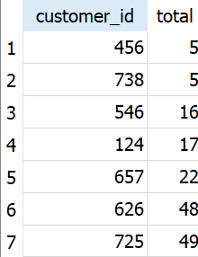

**5.What is the most profitable City in the State of Tennessee?**

SELECT shipping_city , sum (order_profits) as profits

FROM orders AS o

JOIN order_details as od on o.order_id = od.order_id

WHERE shipping_state = 'Tennessee'

GROUP by 1

Order by 2 DESC

LIMIT 5 ;

**Answer :** 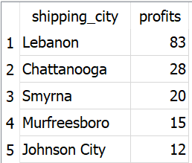

**6.What’s the average annual profit for that city across all years in that city?**

SELECT avg(order_profits)

FROM orders as o

JOIN order_details as od

ON o.order_id=od.order_id

WHERE shipping_city='Lebanon'

**Answer: 27.6666666666667**

**7. What is the distribution of customer types in the data?**

SELECT customer_segment , count(customer_segment)

FROM customers

group by 1

**Answer:**

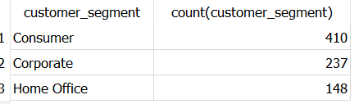

**8. What’s the most profitable product category on average in Iowa across all years?**

SELECT avg(order_profits),product_category, shipping_state

FROM orders as o

JOIN order_details as od

ON o.order_id=od.order_id

JOIN product as p

on od.product_id=p.product_id

WHERE shipping_state='Iowa'

GROUP by 2

ORDER by 1 DESC

**Answer: Furniture**

**9. What is the most popular product in that category across all states in 2016?**

SELECT p.product_name, sum(od.quantity) as total_quantity

FROM orders AS o

JOIN order_details as od on o.order_id = od.order_id

JOIN product as p on od.product_id = p.product_id

WHERE p.product_category = 'Furniture' AND substr(order_date, -4)= '2016'

group by p.product_name

Order by total_quantity DESC

**Answer: Global Push Button Manager's Chair, Indigo**

**10. Which customer got the most discount in the data? (in total amount)**

select cus.customer_id ,cus.customer_name

, sum((od.order_sales / (1-od.order_discount )) - od.order_sales) as total_discount_amount

from order_details as od

join orders as o

on o.order_id=od.order_id

join customers as cus

on cus.customer_id= o.customer_id

group by 2

order by 3 desc

limit 1

**Answer:** 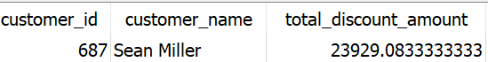

**11. How widely did monthly profits vary in 2018?**

WITH monthly_profit as (SELECT CAST(substr(o.order_date, 1 ,(instr(o.order_date, '/') -1)) as int) month , sum(od.order_profits)as profit

from order_details od

JOIN orders o on od.order_id = o.order_id

where substr(order_date , -4) = '2018'

group by substr(o.order_date ,1 , (instr(o.order_date , '/')-1))

order by month , sum(od.order_profits) DESC)

select month, profit ,lag(profit, 1) OVER (order by month ) prev_month_profit , profit - (lag(profit,1) over (order by month)) difference

from monthly_profit

order by 4

**Answer:**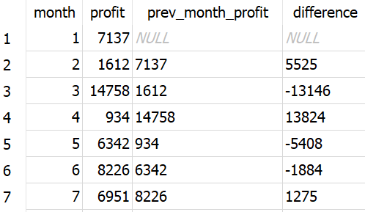

**12.Which order was the highest in 2015?**

SELECT od.order_sales as totalsales, shipping_date, od.order_id

FROM order_details AS od

JOIN orders as o on od.order_id = o.order_id

WHERE shipping_date LIKE '%2015'

ORDER by 1 DESC;

**Answer : CA-2015-145317**

**13.What was the rank of each city in the East region in 2015?**

SELECT sum(quantity ) as sq, shipping_city, shipping_region,

ROW_NUMBER() OVER( ORDER BY quantity) AS rank

FROM order_details AS od

JOIN orders as o on od.order_id = o.order_id

WHERE shipping_region = 'East' and shipping_date like '%2015'

GROUP by 2

ORDER by 1 desc

**14.Join all DB tables into one dataset that includes all unique columns and download it as a csv file. In the second part of the project, you're gonna work with this one table.**

SELECT c.customer_id, c.customer_name, c.customer_segment,o.order_id, o.order_date,

o.shipping_city, o.shipping_country, o.shipping_state, o.shipping_region, o.shipping_postal_code, o.shipping_date, o.shipping_mode,

od.order_details_id, od.product_id, od.quantity, od.order_discount, od.order_profits, od.order_profit_ratio, od.order_sales,

p.product_name, p.product_category, p.product_subcategory, p.product_manufacturer

FROM customers c JOIN orders o on c.customer_id = o.customer_id

JOIN order_details od on od.order_id = o.order_id

JOIN product p on p.product_id = od.product_id;

1. **How many Customers do we have in the data?**
2. **What was the city with the most profit for the company in 2015 and how much was it?**
3. **How many different cities do we have in the data?**
4. **Show the total spent by customers from low to high.**
5. **What is the most profitable City in the State of Tennessee?**
6. **What’s the average annual profit for that city across all years in that city?**
7. **What is the distribution of customer types in the data?**
8. **What’s the most profitable product category on average in Iowa across all years?**
9. **What is the most popular product in that category across all states in 2016?**
10. **Which customer got the most discount in the data? (in total amount)**
11. **How widely did monthly profits vary in 2018?**
12. **Which order was the highest in 2015?**
13. **What was the rank of each city in the East region in 2015?**
14. **Join all DB tables into one dataset that includes all unique columns and download it as a csv file. In the second part of the project, you're gonna work with this one table.**